LP Vari-Flex

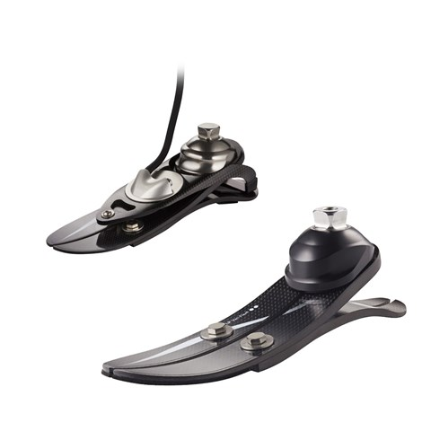
25.4 mm
222.5 mm
63.5 mm

